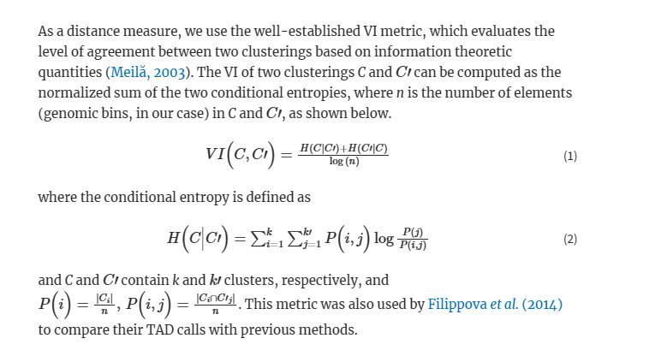

[localtadsim/go/src/localdiff/main.go at master · Kingsford-Group/localtadsim (github.com)](https://github.com/Kingsford-Group/localtadsim/blob/master/go/src/localdiff/main.go)

Two class or structure types: Condentropy (fields are condh1, condh2 and one other), bdyvi (start, end oval one other)

* Pseudocode
  + Clustering
  + Compute VI (variation of information) metric (how much two clusterings align...) (takes two clusterings as input), (measure similarity of two TAD structures...)
  + Resolve initial single tads, compute tad boundaries between pairs,
  + Dynamic programming -> compute multiple VI distances....
  + Select statistically significant regions through adapted permutation test
* Functions hierarchy
  + Clustering method
  + Tad calling -> get TAD boundaries
  + Compute VI (at boundaries)
    - Input: two clustering
    - Output: VI metric for al cluster pairings
    - To produce output, Dynamic programming for all pairings
      * In practice, rather than calculating the entire matrix of VI values for every possible chromosomal sub-interval, we only compute sub-intervals that begin and end at TAD boundaries.
  + Permutation test
  + Select statistically significant regions
    - Use adapted permutation test....
    - BH test...